Desain Kontroler Quadcopter – Input (Hanya Posisi

1. Desain Kontroler Proportional (P)
   1. Lintasan 1 : Circular

|  |  |  |  |  |  |  |
| --- | --- | --- | --- | --- | --- | --- |
| Gain |  |  |  |  |  |  |
|  |  |  |  |  |  |  |
|  |  |  |  |  |  |  |





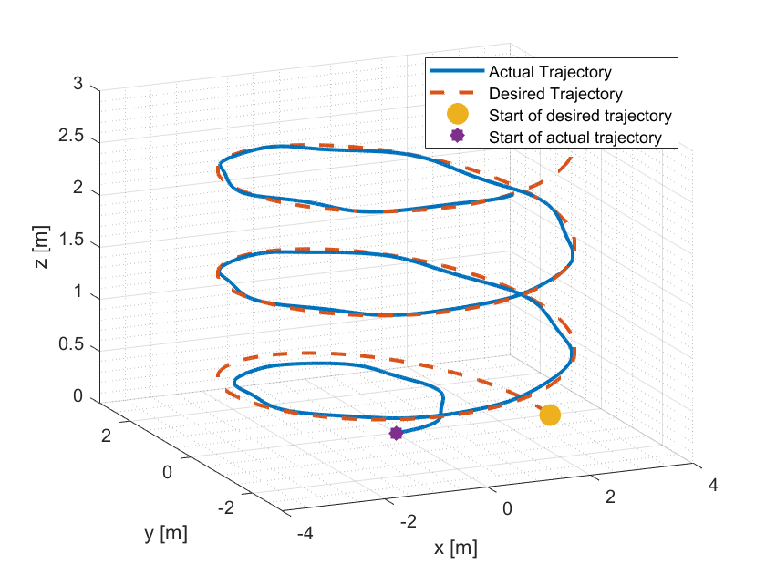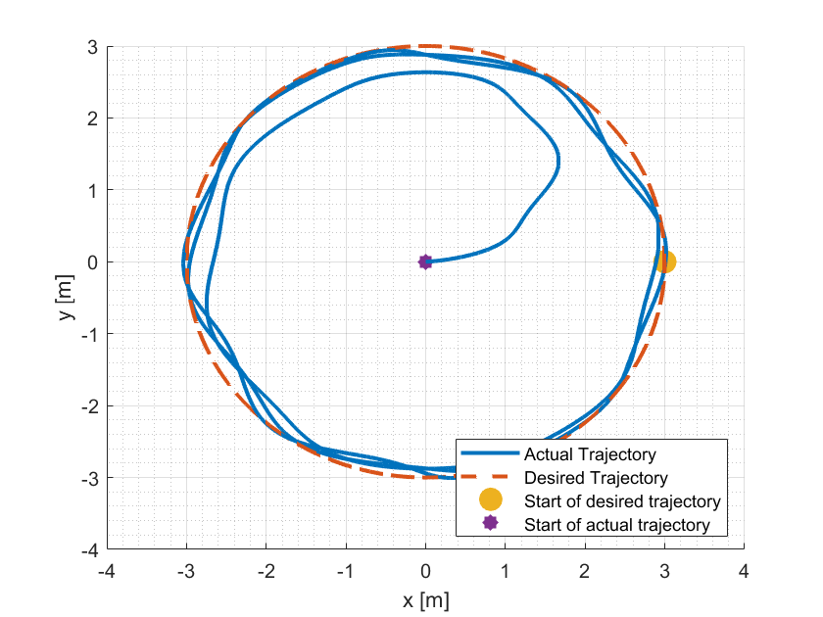

* 1. Lintasan 2 : Spiral

|  |  |  |  |  |  |  |
| --- | --- | --- | --- | --- | --- | --- |
| Gain |  |  |  |  |  |  |
|  |  |  |  |  |  |  |
|  |  |  |  |  |  |  |





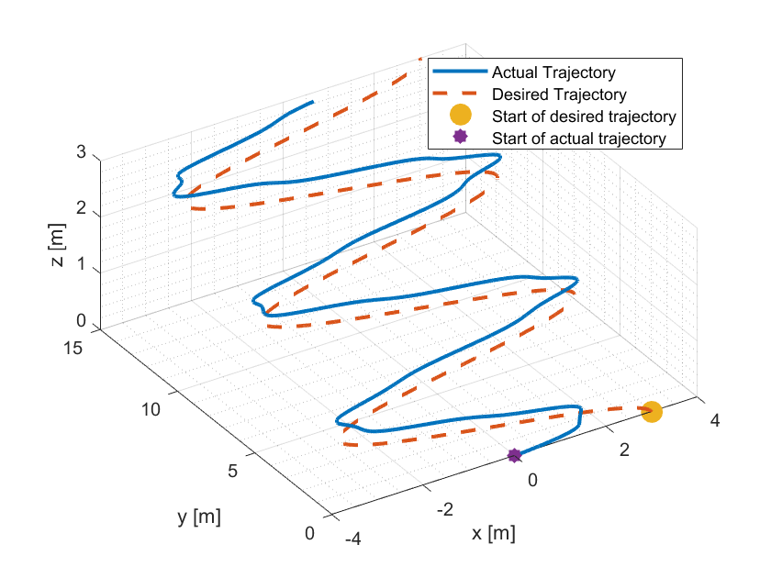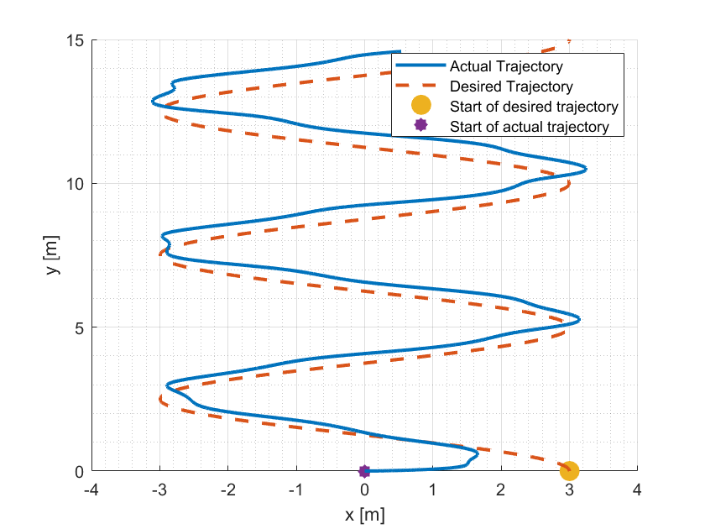

* 1. Lintasan 3 : Lemniscate / 8

|  |  |  |  |  |  |  |
| --- | --- | --- | --- | --- | --- | --- |
| Gain |  |  |  |  |  |  |
|  |  |  |  |  |  |  |
|  |  |  |  |  |  |  |





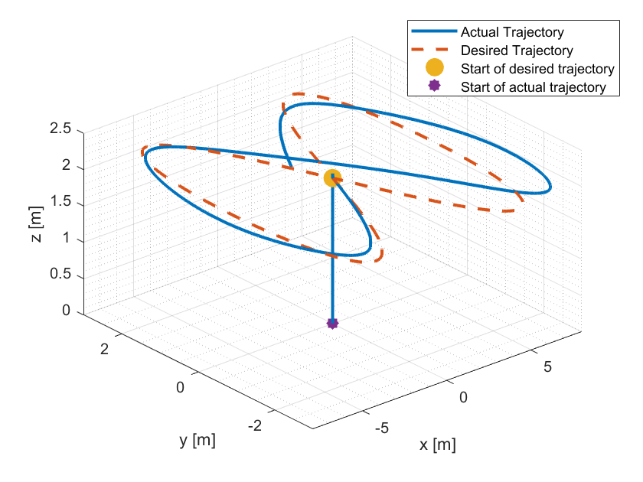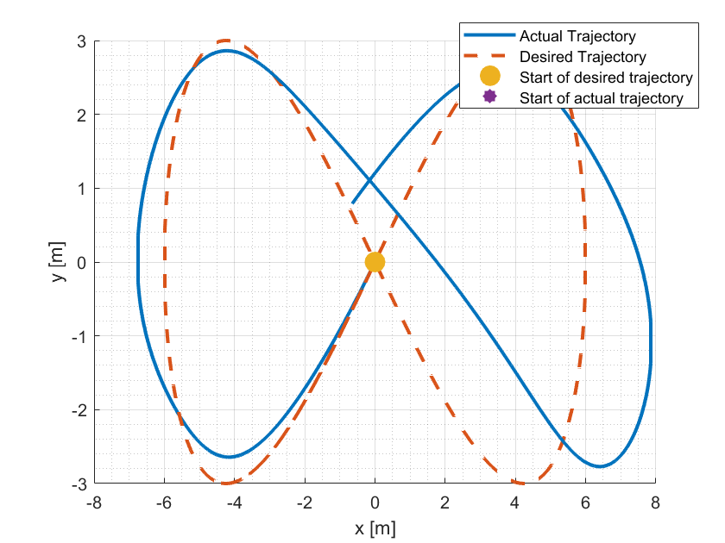

1. Desain Kontroler Proportional-Integral (PI)
   1. Lintasan 1 : Circular

|  |  |  |  |  |  |  |
| --- | --- | --- | --- | --- | --- | --- |
| Gain |  |  |  |  |  |  |
|  |  |  |  |  |  |  |
|  |  |  |  |  |  |  |
|  |  |  |  |  |  |  |





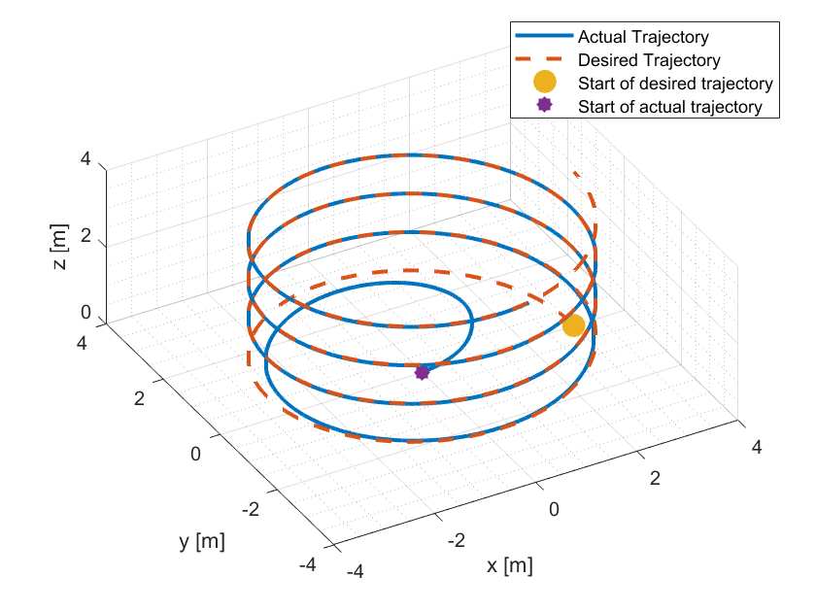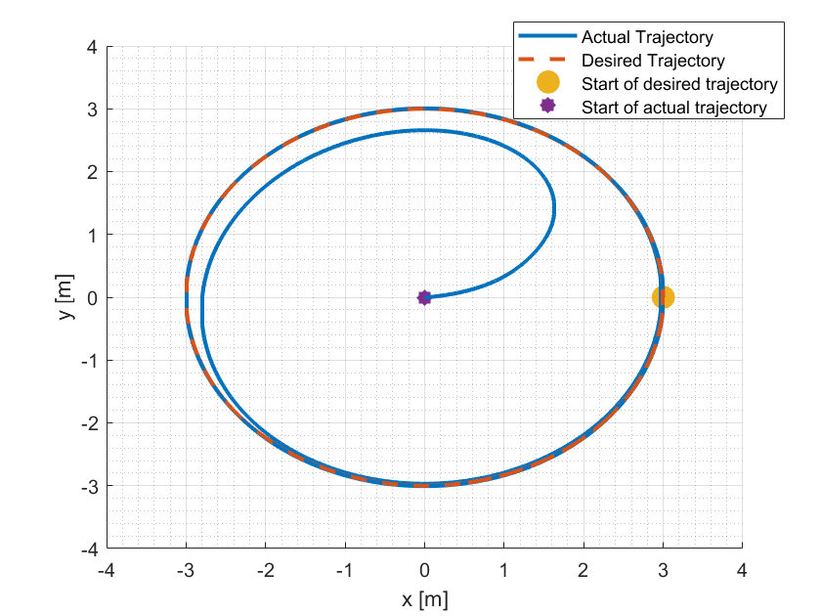

* 1. Lintasan 2 : Spiral

|  |  |  |  |  |  |  |
| --- | --- | --- | --- | --- | --- | --- |
| Gain |  |  |  |  |  |  |
|  |  |  |  |  |  |  |
|  |  |  |  |  |  |  |
|  |  |  |  |  |  |  |





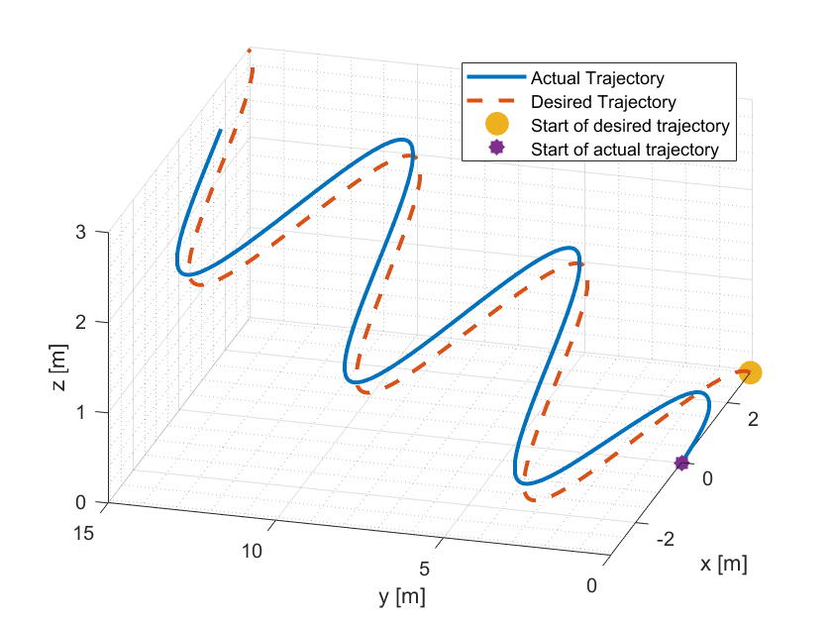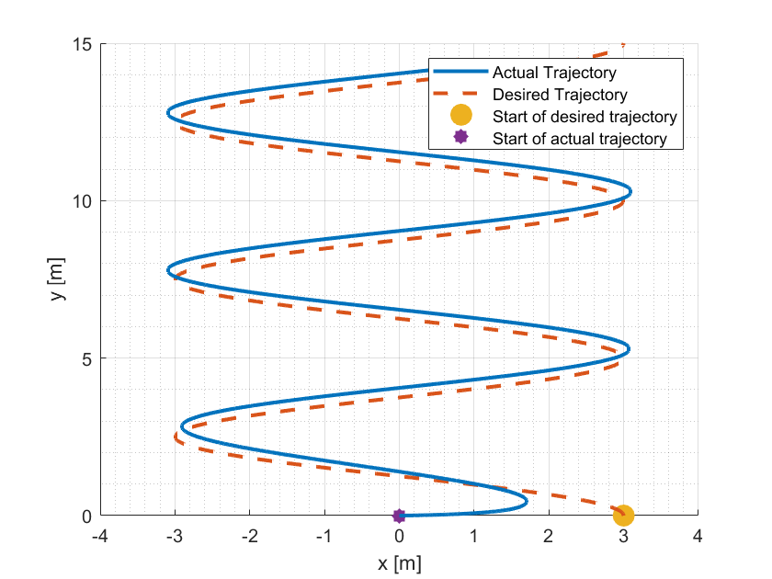

* 1. Lintasan 3 : Lemniscate / 8

|  |  |  |  |  |  |  |
| --- | --- | --- | --- | --- | --- | --- |
| Gain |  |  |  |  |  |  |
|  |  |  |  |  |  |  |
|  |  |  |  |  |  |  |
|  |  |  |  |  |  |  |





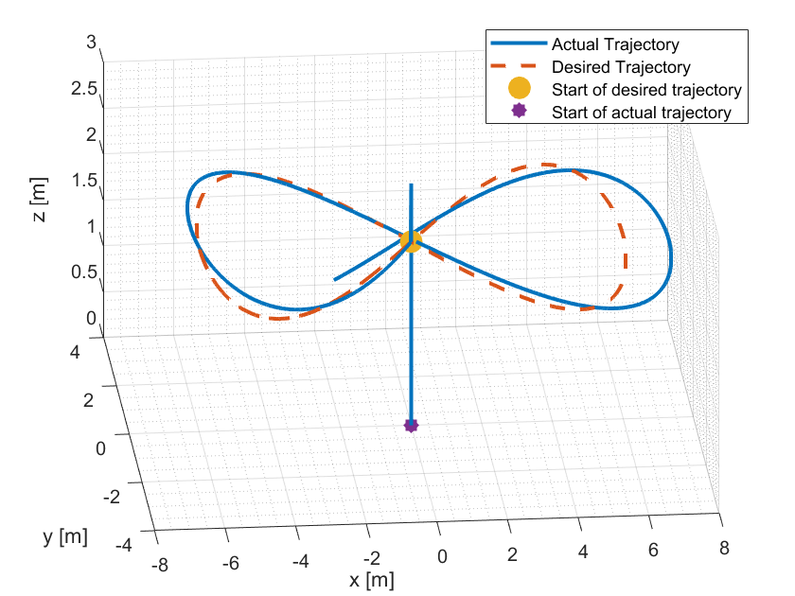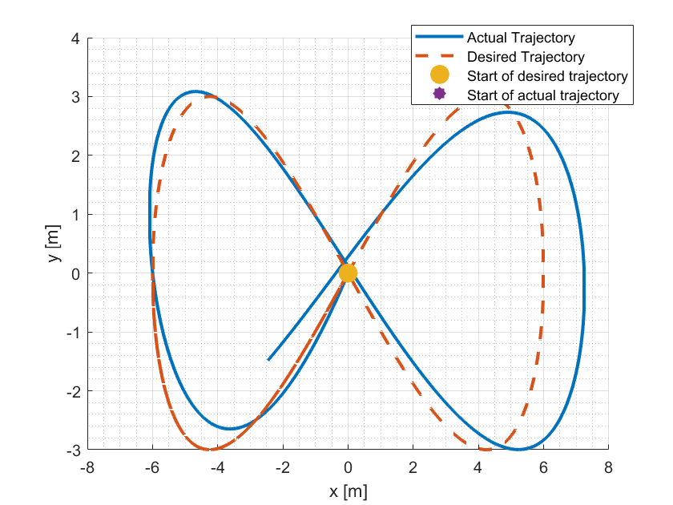

1. Desain Kontroler Proportional-Derivative (PD)
   1. Lintasan 1 : Circular

|  |  |  |  |  |  |  |
| --- | --- | --- | --- | --- | --- | --- |
| Gain |  |  |  |  |  |  |
|  |  |  |  |  |  |  |
|  |  |  |  |  |  |  |
|  |  |  |  |  |  |  |





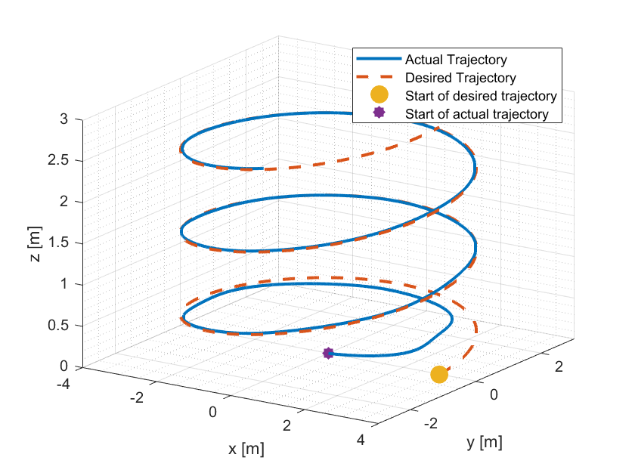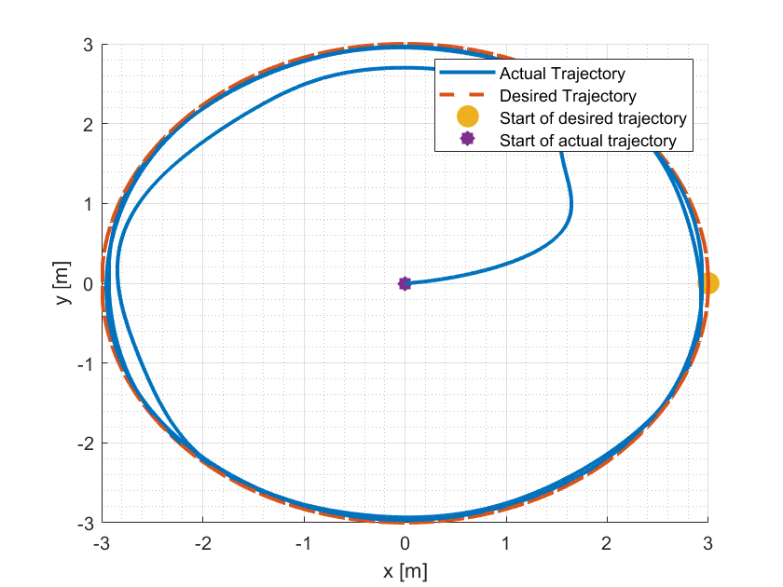

* 1. Lintasan 2 : Spiral

|  |  |  |  |  |  |  |
| --- | --- | --- | --- | --- | --- | --- |
| Gain |  |  |  |  |  |  |
|  |  |  |  |  |  |  |
|  |  |  |  |  |  |  |
|  |  |  |  |  |  |  |





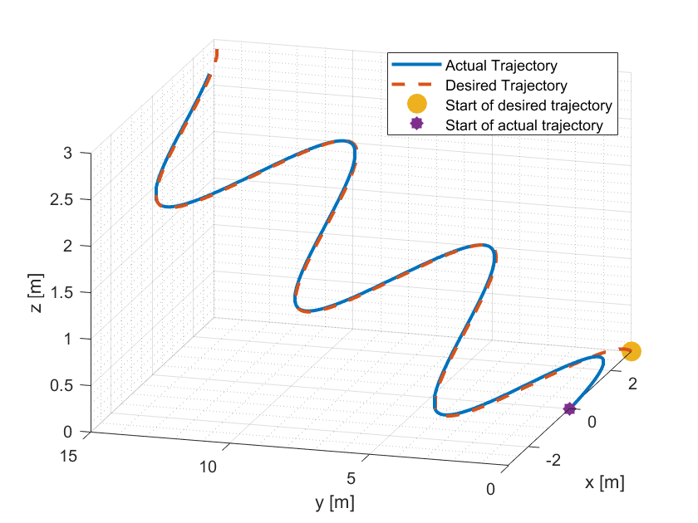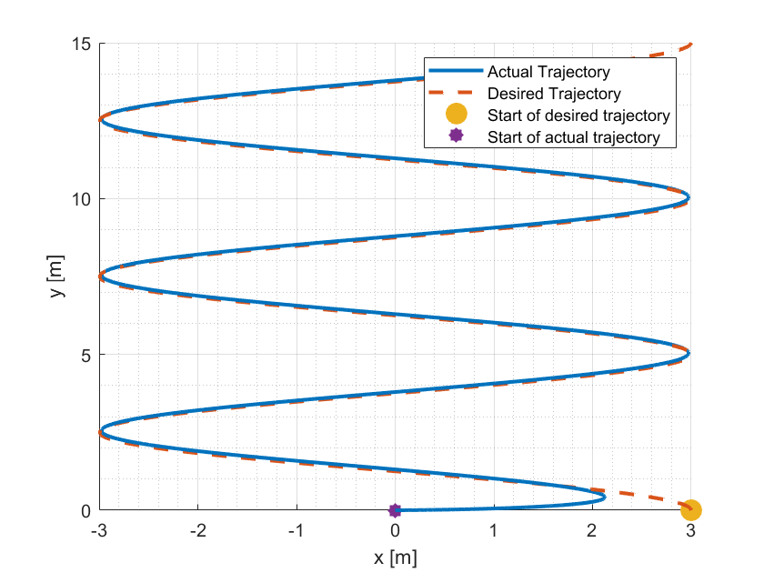

* 1. Lintasan 3 : Lemniscate / 8

|  |  |  |  |  |  |  |
| --- | --- | --- | --- | --- | --- | --- |
| Gain |  |  |  |  |  |  |
|  |  |  |  |  |  |  |
|  |  |  |  |  |  |  |
|  |  |  |  |  |  |  |





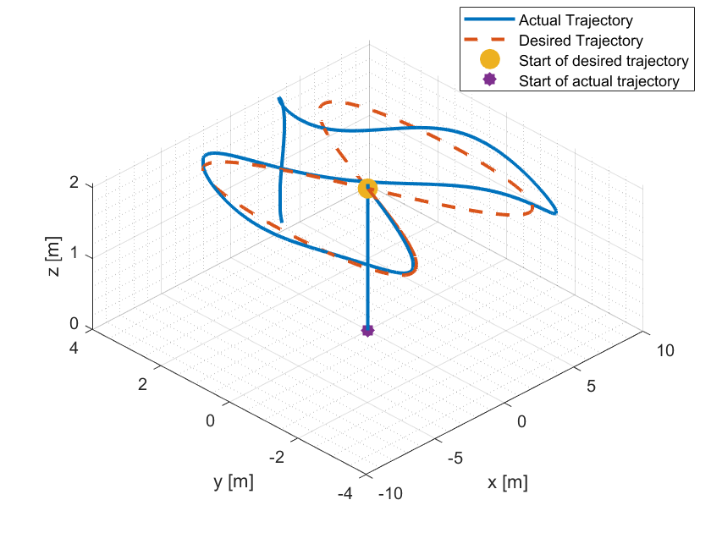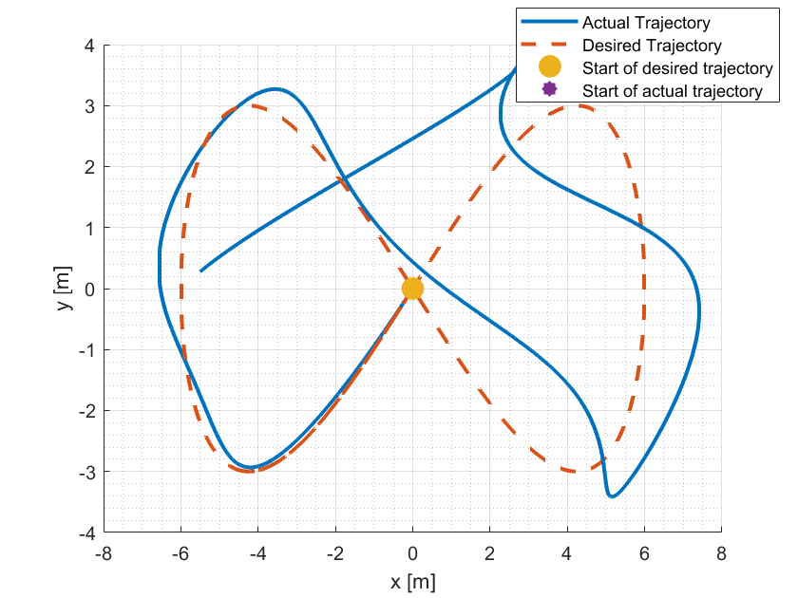

1. Desain Kontroler Feedback Linearization
   1. Lintasan 1 : Circular





